**#FunTimesWithTheTA   
Pianissimo**

**Introduction**

In this installment of #FunTimesWithTheTA we will build a circuit that acts similarly to a miniature piano. With pianissimo we will be able to create music with the equivalent of a piano (if that piano had three keys).

**Learning Objectives**

1. Observe a new application of the charging and discharging capabilities of a capacitor
2. Investigate ability of filters to selectively attenuate either high frequency components (Low Pass) or low frequency components (High Pass) of signals.
3. Use amplifiers to combine signals
4. Create a circuit that can create music

**ABET Outcomes**

“an ability to function effectively on a team whose members together provide leadership, create a collaborative and inclusive environment, establish goals, plan tasks, and meet objectives” (Outcome 5)

“an ability to develop and conduct appropriate experimentation, analyze and interpret data, and use engineering judgment to draw conclusions” (Outcome 6)

“an ability to acquire and apply new knowledge as needed, using appropriate learning strategies.” (Outcome 7)

http://www.abet.org/accreditation/accreditation-criteria/criteria-for-accrediting-

engineering-programs-2018-2019/

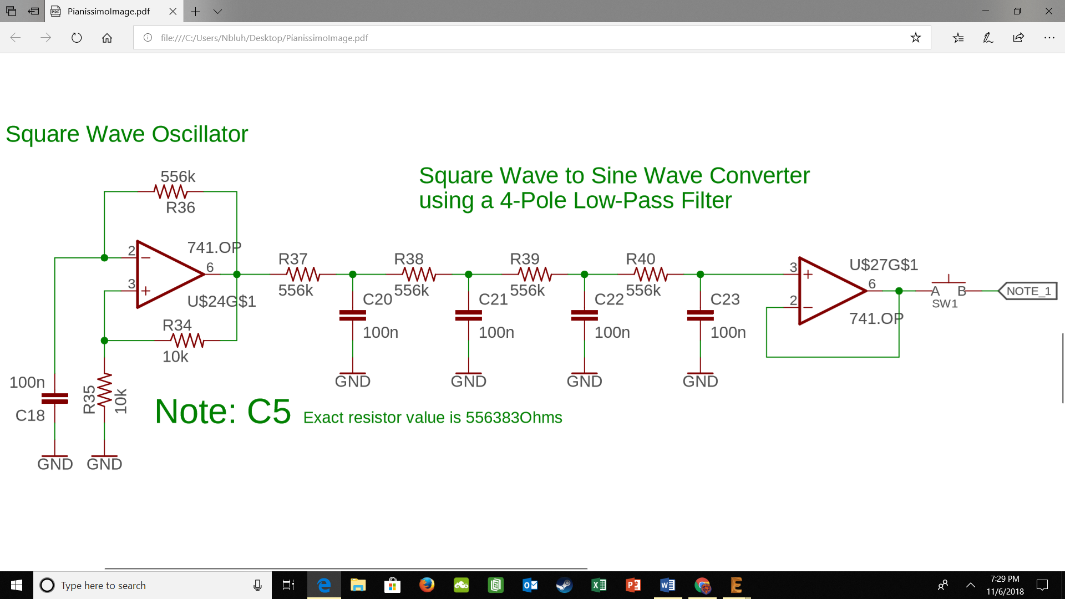

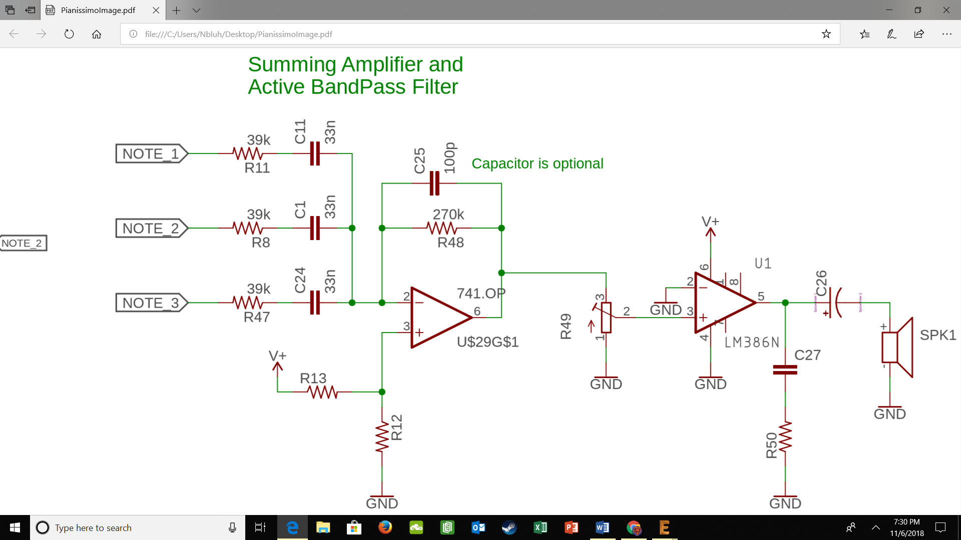

*Figure 1: Circuit diagram of Pianissimo*

**Table of Contents**

|  |  |
| --- | --- |
| **Section** | **Page** |
| Introduction | **1** |
| Objectives | **1** |
| Pianissimo Schematic | **2** |
| Key Terms and Definitions | **4** |
| Part #1: Square Wave Generator | **5** |
| Part #2: Square Wave to Sine Wave Converter | **7** |
| Part #3: Summing Amplifier and Bandpass Filter | **8** |
| Part #4: LM386 and Speaker | **10** |
| Revision History | **12** |

**Key Terms and Definitions**

***Voltage Divider***

A resistor network where two resistors are placed in series so that the input voltage is split between the two resistors.

***Cut-off frequency***

The frequency at which a filter begins to attenuate signals. Typically defined as the frequency at which the output of the filter is 70.7% of the input signal.

***Attenuation***

A decrease in signal amplitude.

***Gain***

An increase in signal amplitude.

***Low-pass Filter***

A type of filter that causes signals with a lower frequency than the specified cut-off frequency to pass with minimal to no attenuation or change in amplitude, but that attenuates signals with frequencies higher than the cut-off frequency.

***Band-pass Filter***

A type of filter than causes signals lower than a given frequency and higher than a given frequency to become attenuated while only passing signals within a given “band” of frequencies. A bandpass filter is a simple combination of a low and a high-pass filter.

***Passband***

The passband refers to the range of frequencies that are not attenuated by a given filter

***Stopband***

The stop band refers to the range of frequencies that are completely attenuated by a given filter.

***Operational Amplifier or Op Amp***

A type of circuit component that can perform mathematical operations on electrical signals such as multiplication, division, logarithm, etc.

***Trim Resistor***

A variable resistance resistor that is used to fine tune circuits to the exact specifications required

**Part #1: Square Wave Generator**

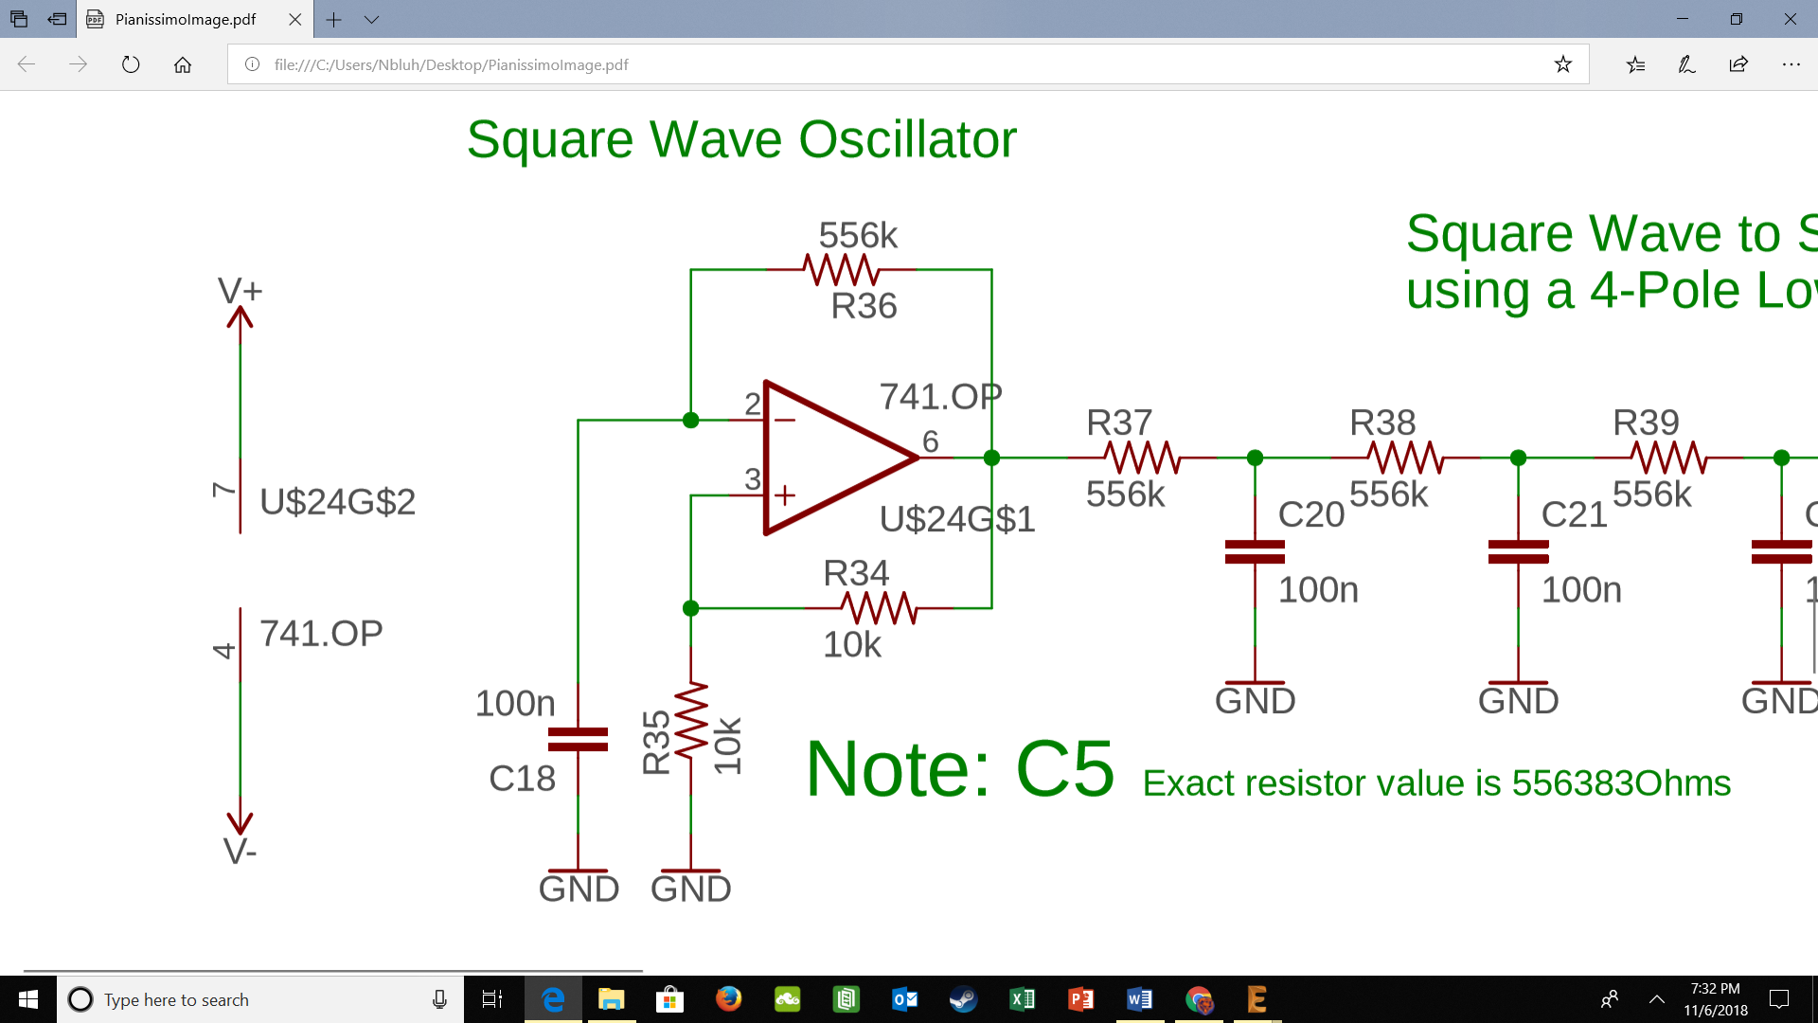

*Figure 2: Square Wave Generator*

The square wave generator pictured in Figure 2 operates on principles that you are already very familiar with. The first principles to note are the rules governing the behavior of ideal op-amps. The voltage at each input pin will be the same and no current can flow into the op-amp through these pins. The second principle to note is the behavior of a capacitor to charge and discharge over time, with the time constant being governed by equation [1].

[1] Tau = Resistance * Capacitance

With the second concept being considered you can see that the capacitor connected to the inverting input of the op-amp will cyclically charge and discharge using ground and the output of the op-amp as its current source. Combine the cyclic charging of the capacitor with the tendency of the op-amp to maintain equal voltages at each input and you get a square wave (approximately) being the voltage output of the op-amp. To create three keys for the piano you will create three different square wave generators, following the above schematic, with the only change being that you substitute the 556k resistor with a 625k and 701k resistors. Doing this creates three distinct square waves, importantly with different frequencies.

***Testing***

1. Assemble the circuit as shown in Figure 2 for the 556k, 625k, and 701k resistors
   1. You should have a total of 3 square wave generators
2. Power the op amps with +5V and -5 from the benchtop power supply.
3. View the output of the square wave generator on your oscilloscope
   1. Hint: it should be a square wave

***Troubleshooting***

1. The most common error here is confusing the non-inverting pin with the inverting pin. Be sure to take a look at the datasheet to ensure that you are connecting the circuit correctly regardless of what the numbers in Figure 2 may say.
2. The second most common error is failing to power the op amp.

**Part #2: Square wave to Sine wave Converter**

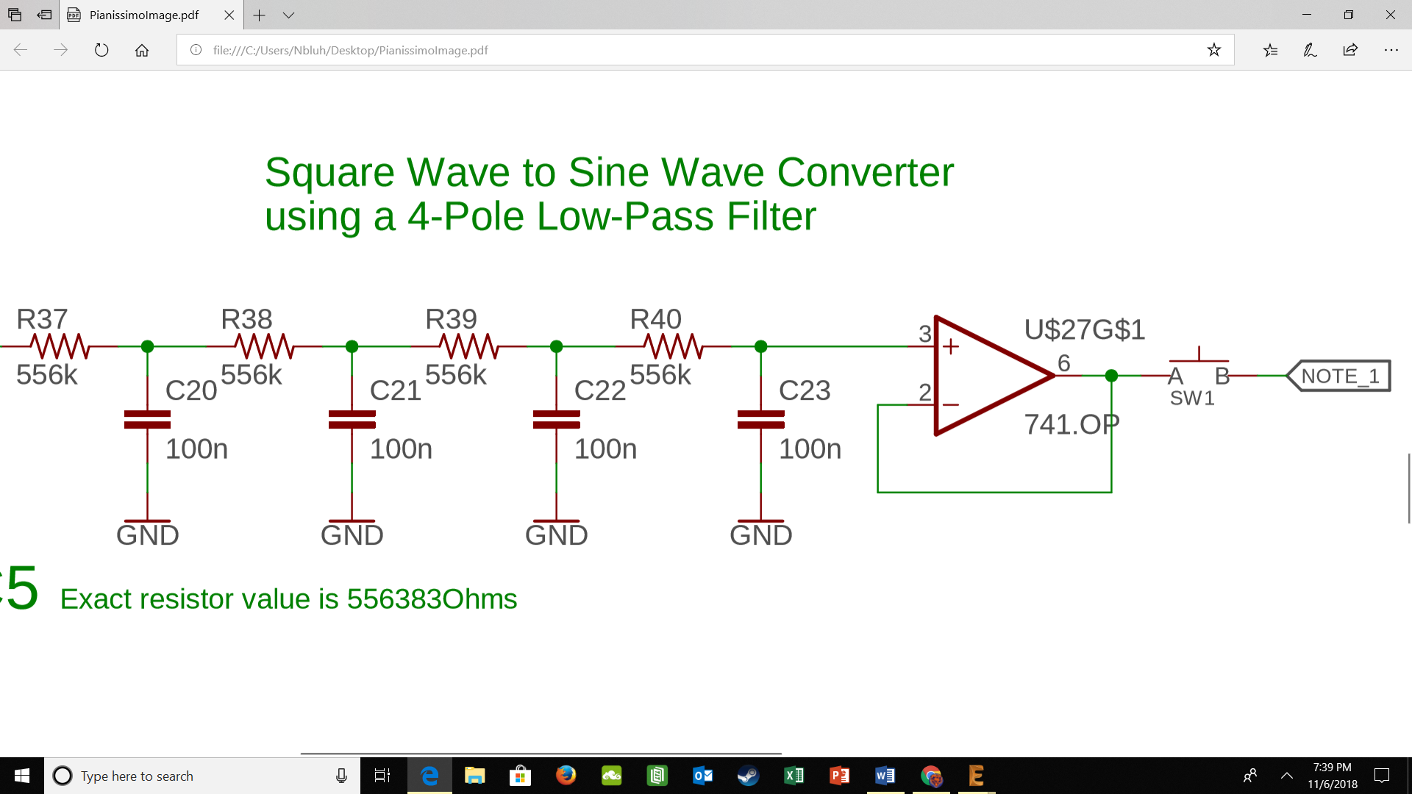

*Figure 3: Square Wave to Sine Wave Converter*

In order to transform the square wave we generated in Part 1 into something we would like to hear, we must convert it into a sine wave. We again do this through concepts that we are already very familiar with, low pass filters. Recall that any periodic wave can be represented by a combination of sine waves at varying frequencies (Fourier Series). To transform the square wave into a sine wave, we would then attenuate some of those components, leaving us with a more traditional sine wave. Using the 4-pole low pass filter shown in Figure 3 we attenuate the higher frequency components of the signal, leaving us with a waveform that is much closer to a sine wave than a square wave. We use a 4-Pole design because the roll-off of the filter is faster than the roll-off of a 1-Pole filter.

Note: We are building three sets of square wave generators and sine wave converters so that we can achieve our “three-key” effect. That is why we use different filters for each of the three sets, creating three distinct frequency waves for each “key”. The filter set for each square wave generator will follow the schematic in Figure 3, with the only component that changes being the 556k resistors, which will change just as they did in Part 1. The square wave generator with the 556k resistors should have the 556k resistors in the filter, while the 625k generator should have 625k resistors in the filter and the same for the 701k generator.

Second Note: We use the voltage follower op-amp at the end of the filters to isolate this stage of the circuit from the rest of the circuit

**Testing:**

1. Assemble the circuit shown in Figure 3 for the 556k, 625k, and 701k resistors
2. View the input and output of the circuit on the oscilloscope
3. Verify that a square wave is inputted into your circuit and a sine wave comes out

**Troubleshooting:**

* Ensure that you have connected all the components properly into the breadboard

**Part #3: Summing Amplifier and Active Bandpass Filter**

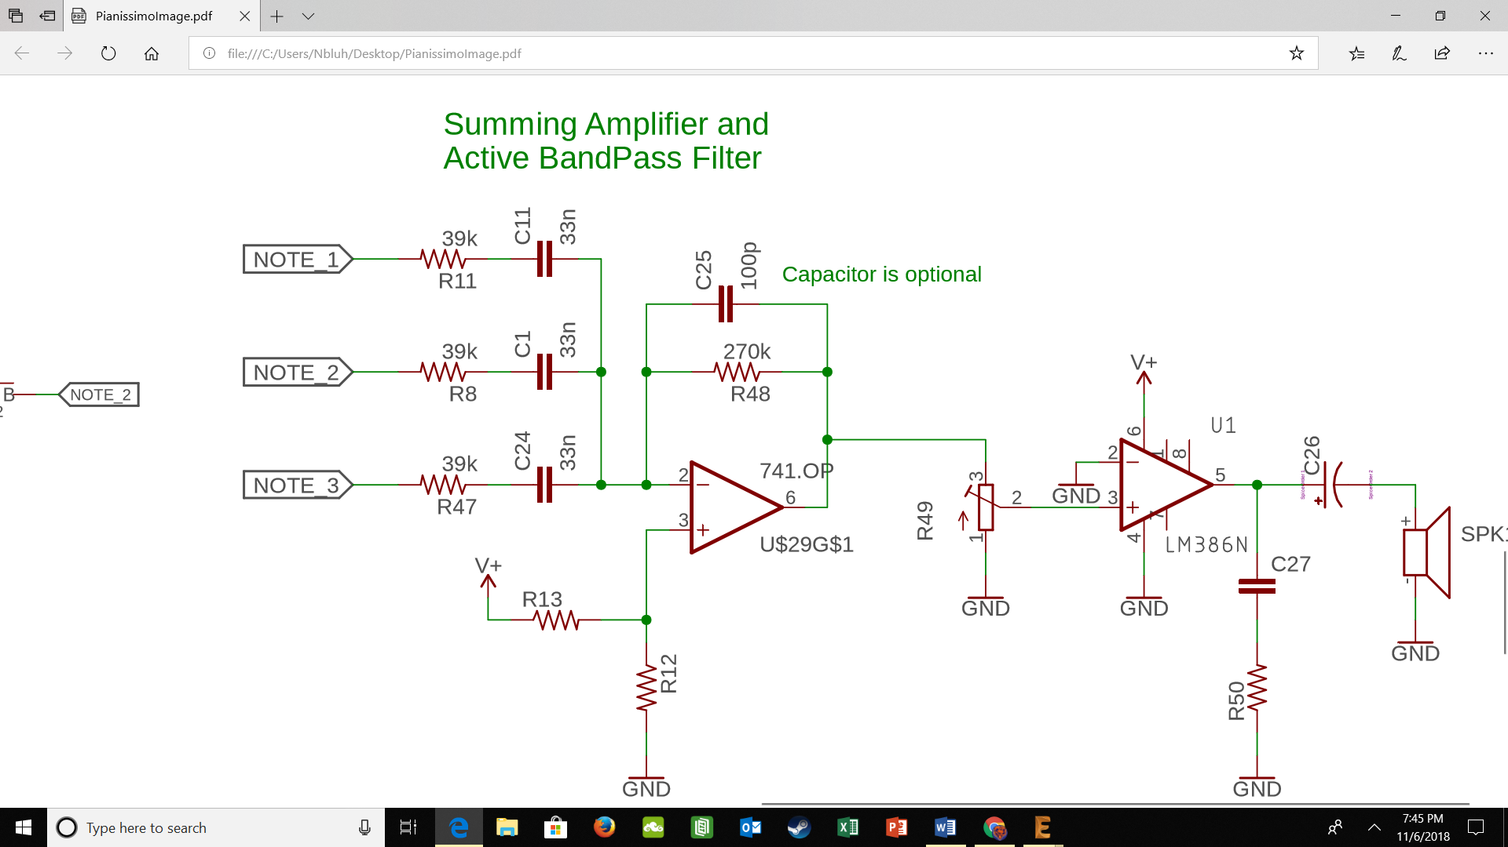

*Figure 4: Summing Amplifier and Active Bandpass Filter*

In order to allow all three of our “keys” to connect to the same speaker we must have some kind of summing circuit that connect them all to the same speaker. Additionally, by summing the three “keys” together, we allow for many more notes to be played. When only one switch is closed, only that note is played, however, when more than one switch is closed both waves will make it to the op-amp and will be summed together into a new note. This summing capability allows us to play many more notes with just three keys. Notice that the op-amp has been biased so that the signal is always positive, oscillating about the voltage that has been input into the non-inverting input. The signal is also being passed through a band-pass filter in this stage, this is to remove unwanted noise from our signals, so that they sound better.

Note: There is a switch (button) that connects the sine wave converter to the summing amplifier, that way the amplifier only receives the signal when the switch is closed (button is pressed), operating like a key on a piano.

**Testing:**

1. Assemble the circuit as shown in Figure 4
2. Create a signal from the function generator that is within the passband of the band-pass filter
3. Input the signal into the circuit where the Note signals would be
4. View the input and output of the circuit on the oscilloscope
5. Verify that you have input the signal from the function generator multiple times and that the output of the amplifier is these inputs summed, inverted, and added to the bias voltage

**Part #4: LM386 and Speaker**

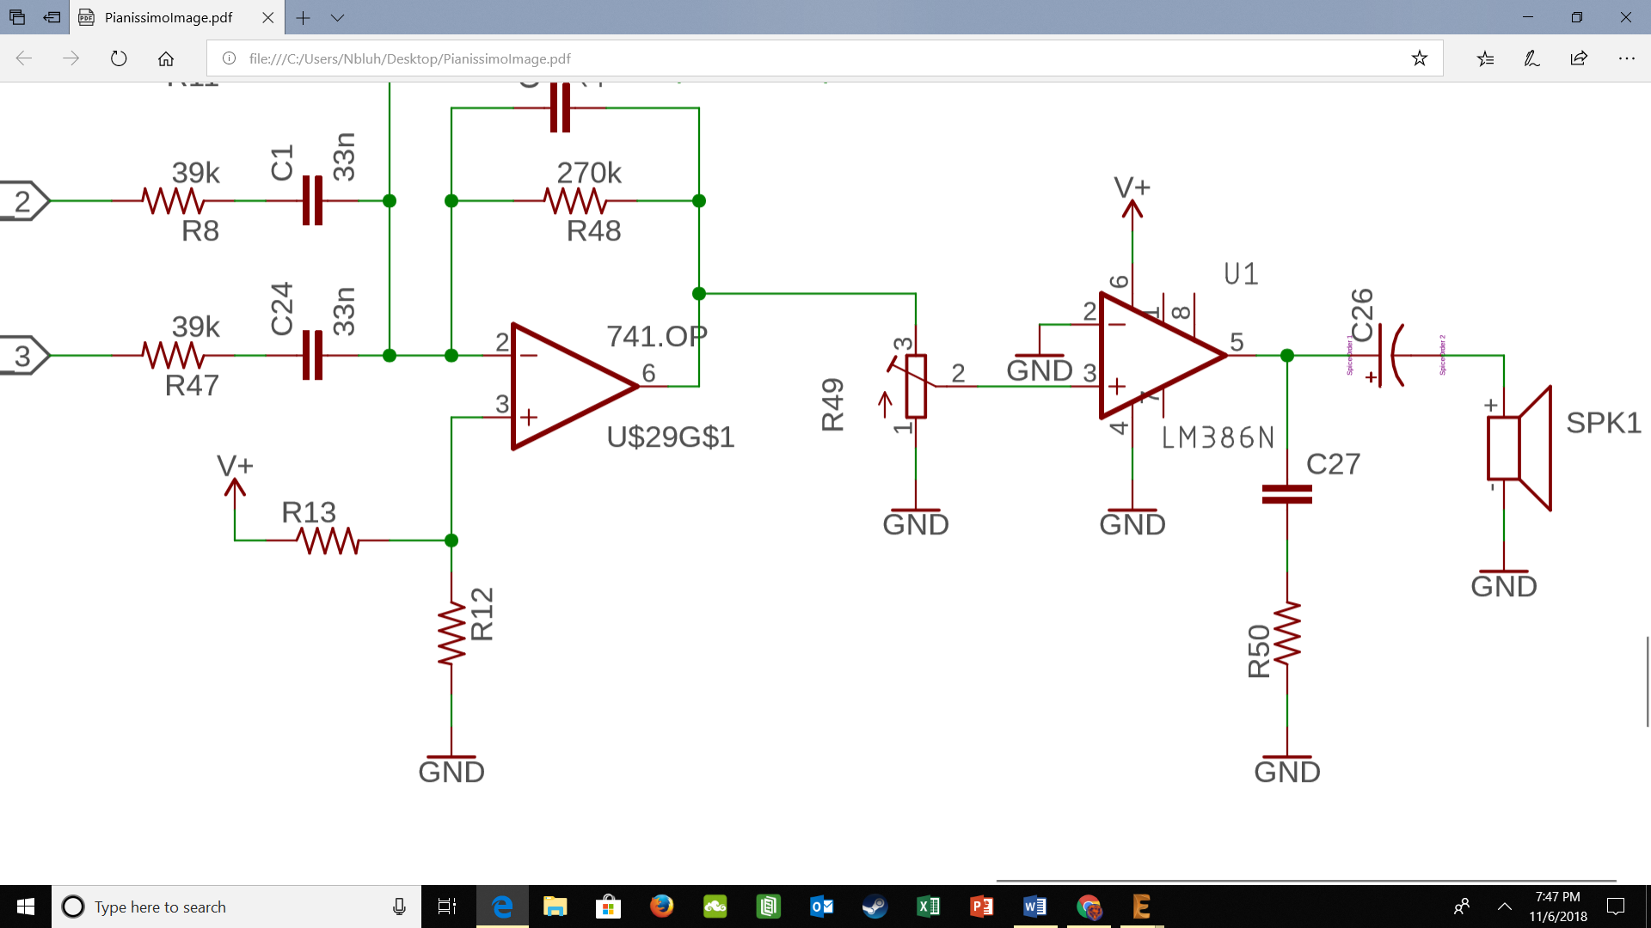

*Figure 5: LM386 and Speaker Circuit Diagram*

The final piece of our little piano is the speaker element that will actually allow us to hear the signals that we have created. This is achieved by first passing the signal from our summing amplifier through a voltage divider (with a trim resistor) and into the LM386. Adjusting the trim resistor allows us to “tune” the signal to exactly the right voltage that we want to input into our Low Voltage Audio Power Amplifier (LM386). The LM386 is a specialized component that prepares our signal to be input into a speaker, find the datasheet here:

<http://www.ti.com/lit/ds/symlink/lm386.pdf>

If you read the datasheet, you’ll notice that we are using the component exactly as described by page 8 of the datasheet, seen below

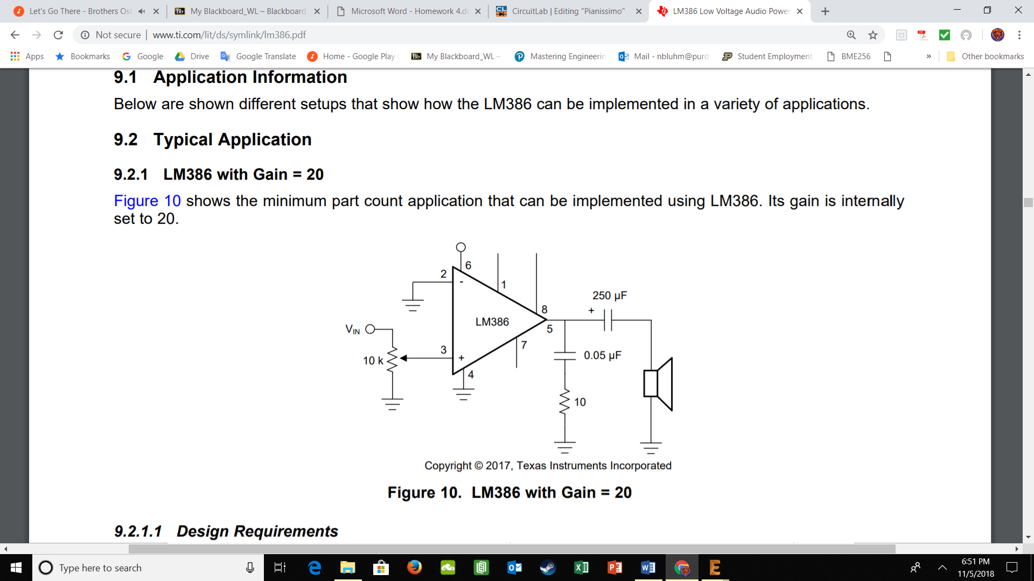

*Figure 6: Image from Page 8 of the Datasheet*

In this configuration the input signal is amplified by 20

**Testing:**

1. Assemble the circuit as shown in Figure 5
2. Input a 100mV sine wave into the circuit
3. Verify that the output is 2 V using the oscilloscope
4. Assemble the whole circuit together and make some tunes!

**Troubleshooting:**

* Make sure that you are connecting the LM386 properly, see Figure 6 for the pin labels or look at the datasheet

**Revision History**

|  |  |  |
| --- | --- | --- |
| **Revision Code** | **Revision**  **Date** | **Description** |
| A | 11/05/2018 | * Initial document for Pianissimo |